**Screenshot – Assignment 4 by Venneti Kalyana Chakravarthy**

**Question 1.1:** 1.1 Write a Python Program (with class concepts) to find the area of the triangle using the below formula.

Area = (s*(s-a)*(s-b)*(s-c)) ** 0.5

Function to take the length of the sides of triangle from user should be defined in the parent  
class and function to calculate the area should be defined in subclass.

**Solution:**

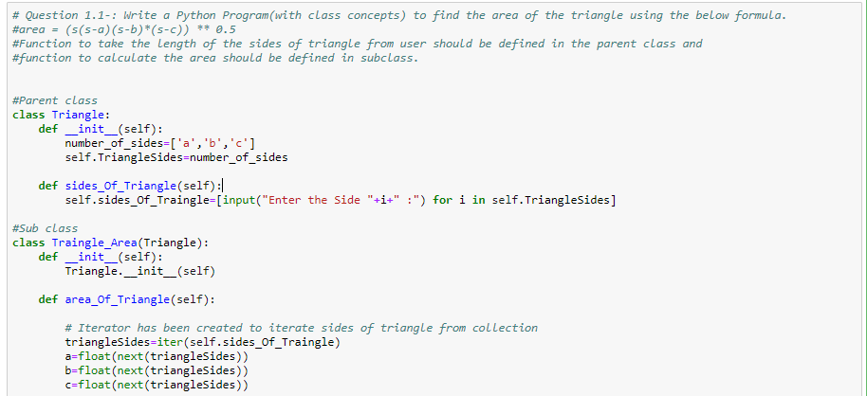

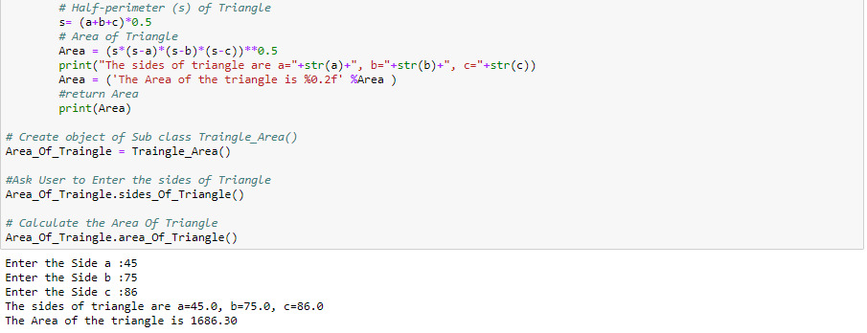

**Question 1.2:** Write a function filter_long_words() that takes a list of words and an integer n and returns the list of words that are longer than n

**Solution:**

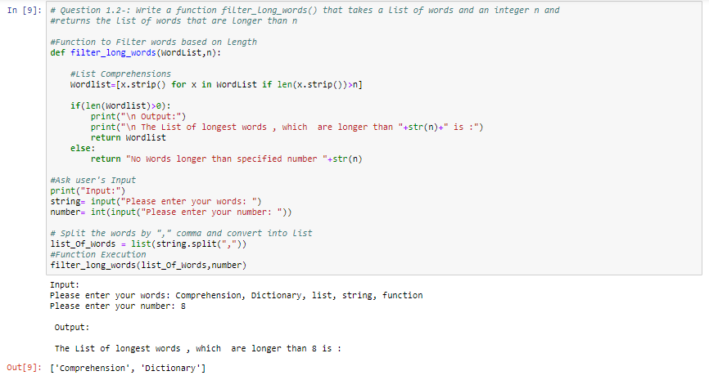

**Question 2.1 :** Write a Python program using function concept that maps list of words into a list of integers representing the lengths of the corresponding words​.  
**Hint:** ​If a list [ ab,cde,erty] is passed on to the python function output should come as [2,3,4]  
Here 2,3 and 4 are the lengths of the words in the list

**Solution:**

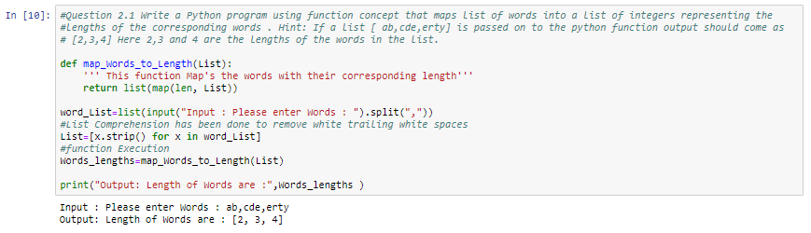

**Question 2.2:** Write a Python function which takes a character (i.e. a string of length 1) and returns True if it is a vowel, False otherwise.

**Solution:**

